**Experiment No:** 6

**Experiment Name :**Implementation of LRU page Replacement Algorithm

**Objectives:** Learn about LRU page replacement algorithm. Emplement LRU page replacement algorithm by using c program. And testing the program different input and find output .

**CODE:**

#include<stdio.h>

void main()

{

int q[20],p[50],c=0,c1,d,f,i,j,k=0,n,r,t,b[20],c2[20];

printf("Enter no of pages: ");

scanf("%d",&n);

printf("Enter the reference string:\n");

for(i=0; i<n; i++)

scanf("%d",&p[i]);

printf("Enter no of frames:\n");

scanf("%d",&f);

q[k]=p[k];

printf("\n\t%d\n",q[k]);

c++;

k++;

for(i=1; i<n; i++)

{

c1=0;

for(j=0; j<f; j++)

{

if(p[i]!=q[j])

c1++;

}

if(c1==f)

{ c++;

if(k<f)

{

q[k]=p[i];

k++;

for(j=0; j<k; j++)

printf("\t%d",q[j]);

printf("\n");

}

else

{

for(r=0; r<f; r++)

{

c2[r]=0;

for(j=i-1; j<n; j--)

{

if(q[r]!=p[j])

c2[r]++;

else

break;

}

}

for(r=0; r<f; r++)

b[r]=c2[r];

for(r=0; r<f; r++)

{

for(j=r; j<f; j++)

{

if(b[r]<b[j])

{

t=b[r];

b[r]=b[j];

b[j]=t;

}

}

}

for(r=0; r<f; r++)

{ if(c2[r]==b[0])

q[r]=p[i];

printf("\t%d",q[r]);

}

printf("\n");

}

}

}

printf("\nNo page faults is %d \n",c);

}

**Output**:

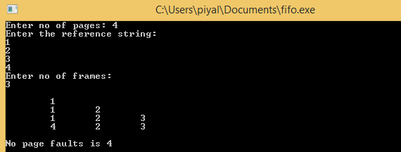

**Discussion:** After doing this lab experiment we learn about LRU page replacement algorithm. We also learn how to implement LRU page replacement by using C program And testing the program different input and find output.And we get proper output.